Enzymes and Energy Quiz Study Guide
- Please fill in the blanks:
An enzyme is usually a(n) that the rate of
BIOMOLECULE INCREASES/DECREASES
chemical reactions by lowering the . TYPE OF ENERGY
- CHECK Endergonic or Exergonic for each reaction characteristic
Reaction term | Energy released | Energy absorbed | Forms bonds | Breaks bonds | Reactants higher in energy than products | Reactants lower in energy than products | Photosynthesis | Cellular respiration
Endergonic
Exergonic

- Write down the formula for photosynthesis:
Circle the reactants and underline the products.

Is this reaction ENDERGONIC or EXERGONIC? Circle one.

- Write down the formula for cellular respiration:
Circle the reactants and underline the products.

Is this reaction ENDERGONIC or EXERGONIC? Circle one.
- Label the graphs A & B below as endergonic or exergonic.

B
A

- Identify which energy graph above matches each chemical reaction below (CIRCLE A or B):
- Cellular Respiration A or B
- Glow stick reaction A or B
- Photosynthesis A or B
- Chemical hand warmer reaction A or B
- Chemical ice pack reaction A or B

- List 2 ways that enzyme activity may be increased in living cells.

- List 5 factors that can stop or slow down enzyme activity in living cells.
Factor | Explain an example of this we saw/talked about in class

- If the substrate concentration within a cell is doubled, what will happen to individual enzyme speed (rate of products produced by the enzyme) over time? (CIRCLE) Increase decrease stay same

- Review possible results for the starch “packing peanut” demo below … Indicate what color each color indicator would be if it was added to the peanut & saliva solution after soaking in human saliva enzymes for 10 minutes:
Color indicator | No hydrolysis reaction yet … ALL STARCH | Some hydrolysis = some STARCH and some GLUCOSE | Hydrolysis complete = ALL GLUCOSE
Iodine color
Benedict’s Solution color
- Define activation energy:

- Explain how activation energy relates to enzyme activity. (i. e., what do enzymes do to this activation energy?)

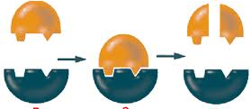
- Label the following features in the figure to the right Substrate: Active site:
Products:
Enzyme

- Identify another term for substrate:

- Explain how can heat denature an enzyme?

- List 2 additional factors that may denature enzymes.

- List 3 reasons why adding a second enzyme to a cell would gradually slow down the speed of the first enzyme?

- Fill in the table below, summarizing the classroom demonstrations we have completed thus far:
Material studied/demo done | Substrate | Enzyme | Cells that contain the enzyme
Starch “Packing Peanut” demo
“smoothies … fizzle out” demo
Dot Lab

- Explain why bubbles form when you put hydrogen peroxide on a cut?

- Diagram a molecule of ATP below. POINT to the location(s) of energy storage within the molecule.

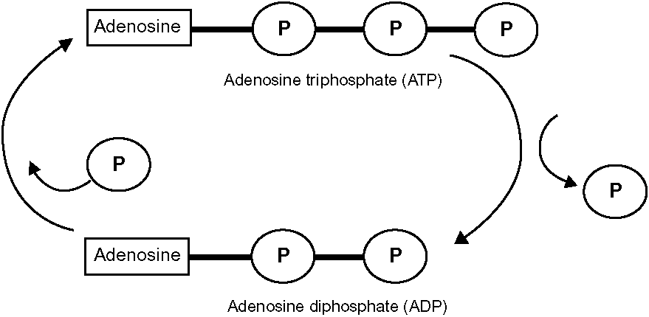
A

B

Study the diagram of ATP formation above and then answer the following 4 questions (21-25)
21. Identify which part of the circular diagram is an endergonic process? (CIRCLE) A B
22. Identify which part of the circular diagram is an exergonic process? (CIRCLE) A B
23. Identify which part of the circular diagram show energy being released for cellular use? (CIRCLE) A B
24. What would you name the enzyme that helps catalyze the hydrolysis of ATP? ________________________
25. How is the stored potential energy within this molecule released?
Analogies. Please complete the analogies below.
26. OSE : carbohydrate :: ____________ : enzyme
27. energy absorbed : endergonic :: energy released : __________________
28. key : lock :: substrate : _______________
29. spark : fire :: ___________________ : chemical reaction
Study the graph below and answer the following questions.

Strangase Robertsase

0 20 40 60 80 100 120 140 160 180 200 220 240

- Provide an appropriate TITLE for this graph:

- At what temperature does Strangase work best?
- At what temperature does Robertsase work best?
- Which enzyme functions over the longest range of temperatures:

- Which enzyme achieves the highest rate of chemical reaction:

- Circle the temperature at which both enzymes work the best: 80 100 120 140 160 200

- Circle the temperature at which NEITHER enzyme would work: 80 100 120 140 160 200

- Circle the temperature at which ONLY Strangase has enzyme activity: 20 50 100 180 200

- As the temperature increases from 50 70 (F), what happens to the rate of Strangase enzyme?
  - It increases
  - It decreases
  - It stays the same
  - It increases at first and then decreases
--------------------------------------------------------------------------------------------------------------------------------
- A student places a piece of radish into a test tube containing H₂O₂ and observes that it bubbles for 4 minutes and then stops bubbling. Predict what will happen if twice as much H₂O₂ is placed into the test tube?
  - It will not bubble
  - It will bubble twice as long (8 minutes)
  - It will bubble for the same amount of time (4 minutes)
  - It will bubble for half the amount of time (2 minutes)

- Suppose a student repeats the Starchase demo using the starch packing peanut. What color do you predict the two indicators will be if the student boils the saliva for 5 minutes before adding the saliva?
Iodine color: ______________ Benedict’s color? _______________

